9.5: a) b)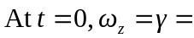
The acceleration is not constant, but increasing, so the angular velocity is larger than the average angular velocity.

